Azure Visual studio Model Building:

=======================================

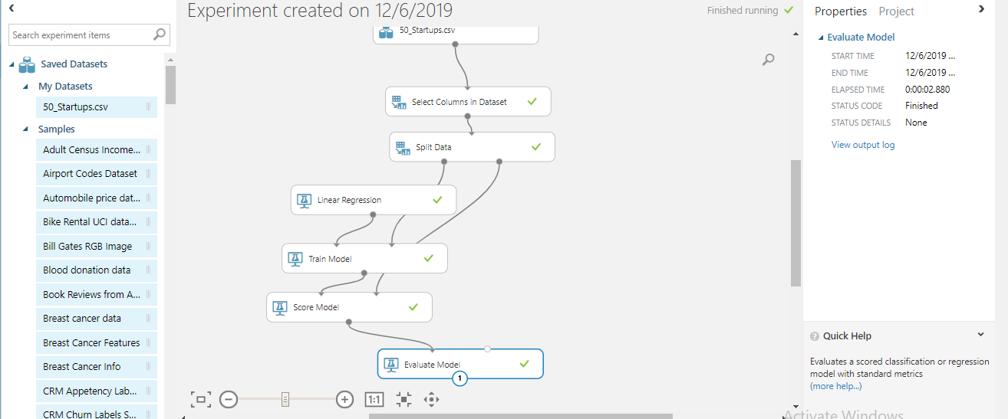

Step1:

Dataset import your own data set.

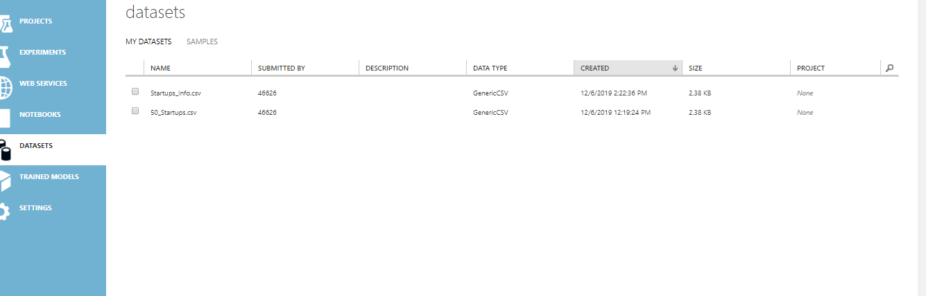

Step2:

Go to experiment

Click + symbol

Choose blank experiment

Step3:

Saved dataset -> mydataset-> drag and drop your data set

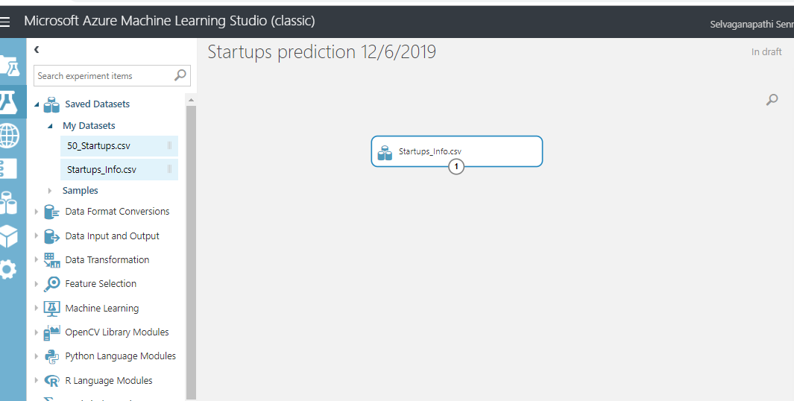

Step4:

Data transformation -> manipulation -> select column in data set

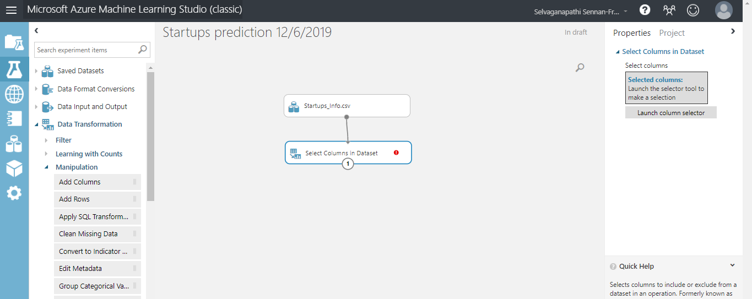

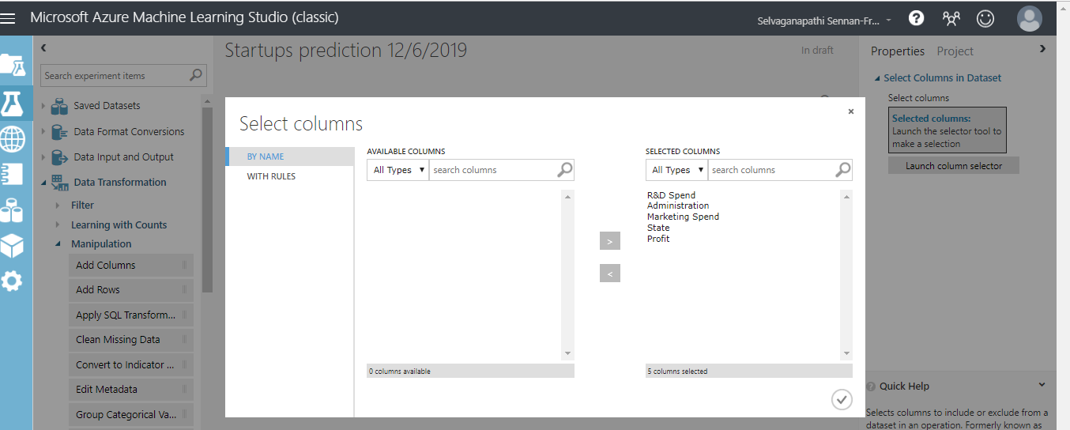

Step5:

Sample and split -> Split Data->

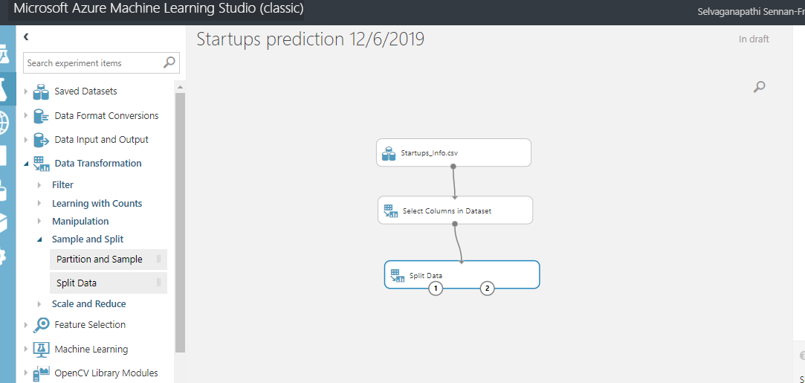

Split Data -> Fraction of rows ->0.7

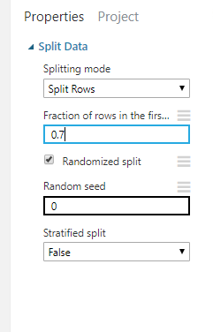

Step 6:

Type regression in search box and choose linear regression

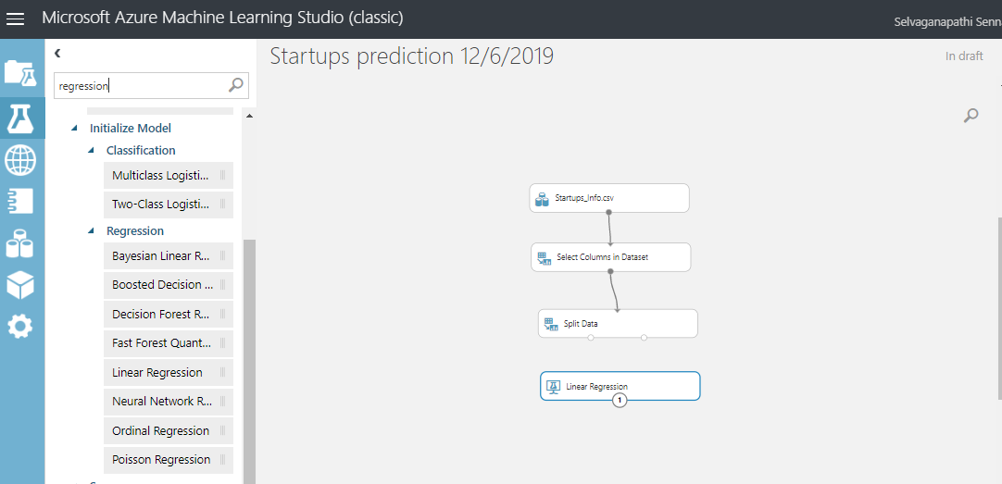

Step 7:

Choose train model and add need to predict column, here profit

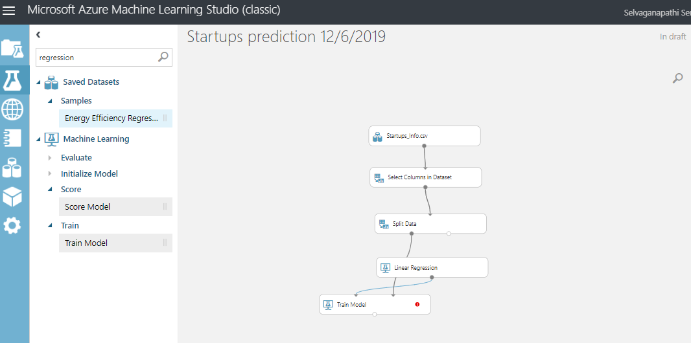

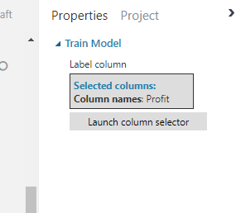

Stpe8 : choose score model

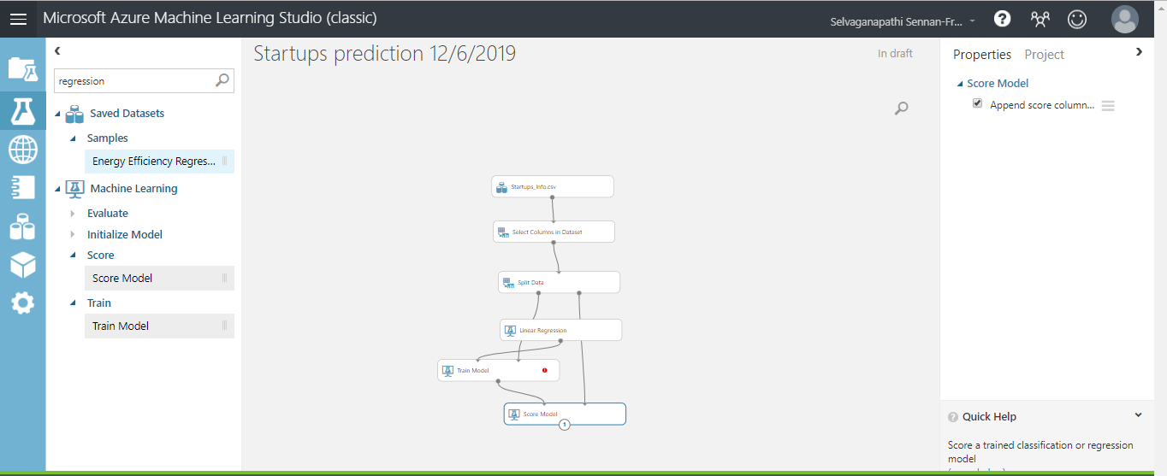

Step 9:

Choose evaluate model

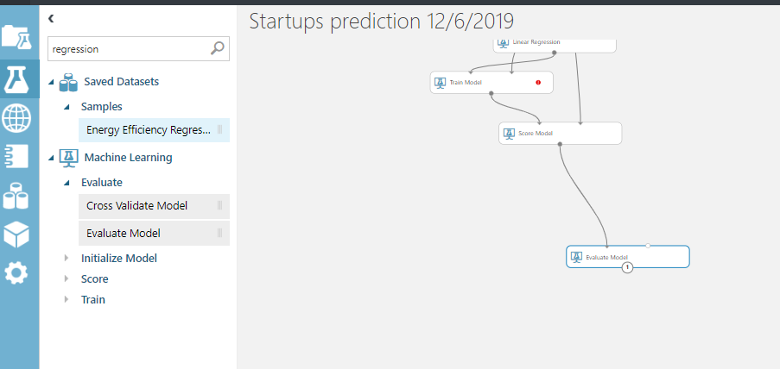

Finally right click evaluate model -> run model

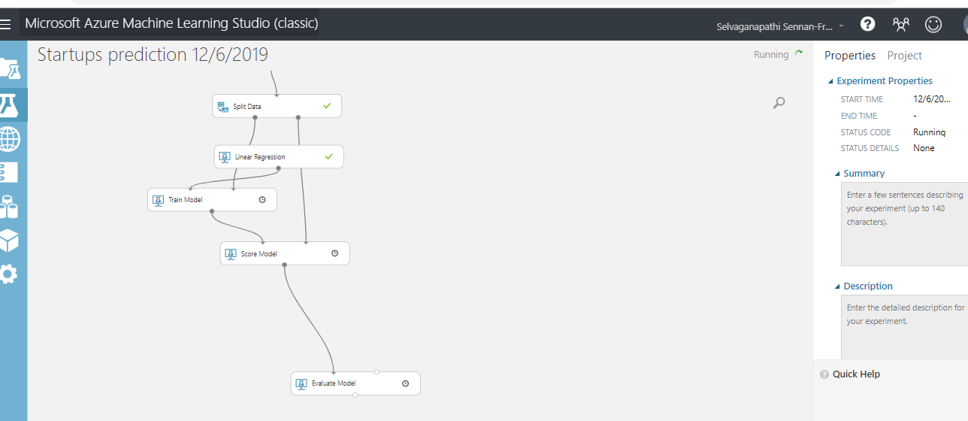

Right click -> evaluate model ->visualize -> coefficient of determination -> you will get the accuracy value

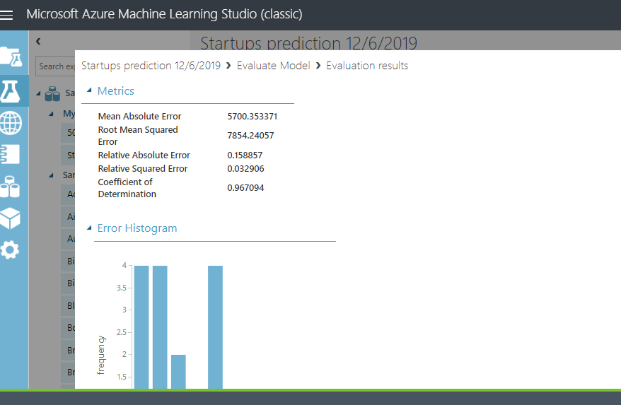

After you deploy your model and predict for your new set of spend input to new profit.

